Chapter 2
Basic Financial Statements
Basic financial statements:
- The income statement shows revenues and expenses.
- The statement of financial position is a listing of all asset, liability, and equity account balances that do not appear on the income statement.
- The statement of cash flows shows how the company receives and spends its cash.
The statement of financial position:
- Describes the financial position of a company at a specific point in time.
- May be prepared monthly, quarterly, or annually depending on the needs of management and external users.
- Sometimes referred to as the statement of financial position.
Income Statement:
- Profit is defined as the excess of revenues over expenses.
- Financial statements begin with a three-line title comprised of the company name, the name of the statement, and the period covered by the report.
- The income statement lists revenues and expenses that were incurred over a period of time.
- Most companies prepare monthly income statements.
- In the long-run, revenues will generate positive cash inflows to the company and expenses will result in negative cash flows to the company.
- Just remember, revenues and expenses that appear on the income statement may not always produce cash flows in the current accounting period.
- Profit (or loss) is simply the difference between revenues and expenses.
- When revenues exceed expenses, the result is profit.
- When expenses exceed revenues, the result is a loss.
Statement of Cash Flows:
- The statement of cash flows is divided into three major sections:
  - cash flows from operating activities
  - cash flows from investing activities
  - cash flows from financing activities
- The statement describes cash inflows and outflows over a period of time.

A Starting Point: Statement of Financial Position
The statement of financial position, commonly referred to as the statement of financial position, is an inventory of assets, liabilities, and equity at the end of the month.
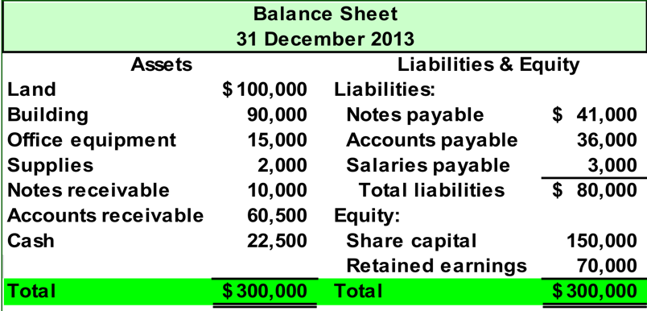
Our total assets are equal to $300,000. This includes cash of $22,500, notes receivable of $10,000, supplies of $2,000, and the balances in the remaining asset accounts. Assets: are resources that are controlled the business and are expected to have future economic benefits flowed to the business.
Liabilities include notes payable of $41,000, accounts payable of $36,000 and salaries payable of $3,000.
The accounts in the equity section of the statement of financial position are share capital of $150,000 and retained earnings of $70,000.
Notice that the total assets are equal to the total liabilities plus equity.
The following accounting principles support cost as the basis for asset valuation:
The business entity principle: states that the transactions of individual owners of a business and those of the business must be separate.
The cost principle tells us that accounting information is based upon actual cost incurred. We refer to this as historical cost.
The going-concern assumption states that in the absence of information to the contrary, the business entity is assumed to continue operations into the foreseeable future.
The objectivity principle states that accounting information must be unbiased and based upon independent evidence.
The stable-dollar assumption: an assumption by accountants that the monetary unit used in the preparation of financial statements is stable over time or changes at a sufficiently slow rate that the resulting impact on financial statements does not distort the information.
Liabilities
- Are debts that represent negative future cash flows for the enterprise.
- Represent the claims of creditors on an entity’s assets.
- Include accounts payable (amounts owed to creditors for assets purchased on account), taxes payable, and wages payable (amounts owed to our employees at the end of the accounting period).
Equity
- Represents the owners’ claims on the assets of the business.
- The equities of an entity include investments by owners, withdrawals by owners, and earnings retained by the business.
- Investments by owners and profits increase equity.
- Payments to owners and losses decrease equity.
Revenues: the price of goods and services charged to customers for goods and services rendered by a business.
Expenses: the costs of the goods and services used up in the process of obtaining revenue.
Adequate disclosure: the accounting principle of providing with financial statements any financial and other facts that are necessary for proper interpretation of those statements.

Accounting Equation
The basic accounting equation states that assets are equal to liabilities plus equity of a company.
The equation makes sense because it states that assets must be equal to the claims against those assets.
There are two broad categories of claims against an asset: Claims by creditors (called liabilities), or after all creditor claims are satisfied, the residual owners (the shareholders) have a claim on those assets.
- Accounting equation: ASSETS = LIABILITIES + OWNER'S EQUITY
- Assets are something the business owns or has control of
- Liabilities are something the business owes
- Equity represents the amount of assets that are left over after the company has paid its liabilities, or net worth
- Transaction analysis using the accounting equation
- Key: Both sides of the accounting equation must always be equal
- financial statements
- Income Statement
- Balance Sheet or statement of financial position (uses the same accounts as the accounting equation)
- Statement of Cash Flows
- Headings on statements always listed as:
- Name of company
- Name of statement
- Descriptive date
- Revenues and expenses affect equity
- Revenues are increases (earned) in equity from providing goods or services to customers
- Expenses are decreases (incurred) in equity through the operation of a business
    - Using up assets
    - Or increasing liabilities
- The major Account categories are Assets, Liabilities, and Stockholder’s Equity
    - Under these Accounts, there are common accounts that occur in most businesses.
      - Assets
        - Cash includes bank account balances and cash on hand.
        - Accounts Receivable represents amounts owed to the business by customers.
        - Notes Receivable represents a written promise (promissory note) that the customer or borrower will pay a fixed amount of money by a certain date. Often includes interest charges.
        - Prepaid Expenses are assets of a business because they represent items that have been purchased but will be used later.
          - Examples include Insurance paid a year in advance.
        - Land is used to track the cost of land a business owns and uses in its operations.
        - Buildings represent the cost of a business’s buildings, offices, warehouses, etc.
        - Equipment, Furniture and Fixtures represent items such computer equipment, office equipment, store equipment, and furniture and fixtures. A business will typically have a separate asset account for each type of equipment.
Liabilities
        - Accounts Payable reflects how much cash the business must pay to suppliers for goods or services that have already been received.
        - Notes Payable represents amounts the business must pay because it signed a promissory note to borrow money.
        - Accrued Liabilities represents liabilities for expenses that have been incurred but have not yet been paid.
          - Examples are Taxes Payable, Interest Payable, and Salaries Payable.
      - Stockholders’ Equity
        - Share capital represents the investment of assets, usually cash, the stockholders have invested into a business in exchange for the company’s stock.
        - Retained Earnings tracks the cumulative earnings of the business since it began, less any dividends given to stockholders.
        - Revenues are increases in Retained Earnings that represent amounts earned by the company.
        - Expenses are decreases in Retained Earnings from using resources to deliver goods and services to customers.
        - Dividends reflect the amount of earnings that have been distributed to the stockholders. Dividends decrease Retained Earnings.

Let’s look at how specific business transactions impact the basic financial statement.
Date | Part I | Part II
May 1 | Jill Jones and her family invested $8,000 in JJ’s Lawn Care Service and received 800 shares of the company in return. Let’s see how the statement of financial position would look immediately after this transaction. | The cash account increased by $8000 and the share capital of the company also increased by $8000. Notice that the basic accounting equation is in balance. Total assets are equal to total liabilities plus equity.
May 2 | JJ’s Lawn Care purchased a riding lawn mower for $2,500 cash. Let’s see how the statement of financial position looks now. | The cash account has been reduced by the $2,500 spent and the tools and equipment account has been increased by the same amount. One asset, cash, was merely traded for another, the riding lawn mower. Equity is not changed by the transaction and the basic accounting equation is still in balance.
May 8 | In the next transaction JJ’s Lawn Care purchases a truck for $15,000, paying $2,000 cash and signing a note payable for $13,000. Let’s update the statement of financial position. | The cash account decreased by $2,000 and the truck account increased by $15,000. There was a net increase in the asset side of the equation of $13,000. The liability account, notes payable, increased by $13,000.  Total assets are now equal to $21,000. Total liabilities are equal to $13,000 and equity is equal to $8,000. The accounting equation is still in balance.
May 11 | JJ’s Lawn Care purchases repair parts for the riding lawn mower for $300. The parts are purchased on account. JJ’s will pay the balance on the account at some point in the future. Let’s update the statement of financial position. | The tools and equipment account increased by $300 and the liability account, accounts payable, increased by the same amount. The statement of financial position is getting progressively more complicated.
May 18 | On 18 May, JJ’s Lawn Care sells one-half of its repair parts at cost to ABC Lawns. ABC agrees to pay for the parts in thirty days. One-half of the cost of the parts is $150. Can you update the statement of financial position? Try before proceeding to the next slide. | The asset account, Tools and Equipment, decreased by $150 and the asset account, accounts receivable, increased by the same amount. Once again, one asset, repair parts, has been exchanged for another asset, accounts receivable. How did you do?
May 25 | ABC Lawns makes a partial payment on account for $75 cash. Let’s prepare the updated statement of financial position on 25 May. | The cash account increases by $75 and accounts receivable decreases by the same amount. Notice that total assets are still equal to total liabilities plus equity.
May 28 | JJ’s Lawn Care makes a partial payment on its accounts payable of $150. Its time to update the statement of financial position. | The cash account decreases by $150 and accounts payable also decreases by $150. The total assets are now recorded at $21,150. Total liabilities plus equity is equal to the same amount.
May 29 | JJ’s Lawn Care begins providing services to customers. On this date the company did work that totaled $750. All of the customers paid cash for the services rendered. Try updating the statement of financial position before moving to the next slide. Be careful with this one. | The cash account increases by $750 and retained earnings increases by the same amount. The monies received represent earnings of the company that have been retained. The $750 represents revenue earned by the business. How did you do?
May 31 | In the final transaction for May, JJ’s Lawn Care purchased $50 worth of gasoline for its riding mower and truck. Let’s make the final update to the statement of financial position on 31 May. | The cash account decreased by $50 and so did the retained earnings of the company. JJ’s Lawn Care used $50 of its earnings to pay for the gasoline. The $50 spent is an expense of the business.  Now, let’s review how JJ’s transactions affected the accounting equation.

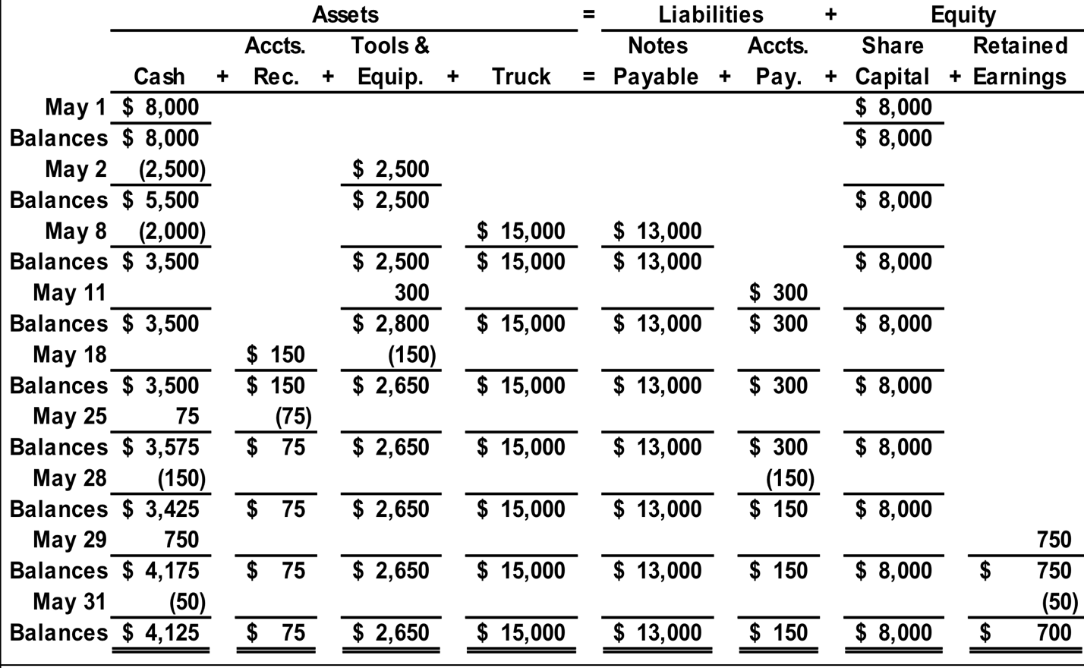 All of these transactions have been placed on this slide, in the appropriate columns for the accounts they’ve impacted. Let’s verify the balance in each account and get ready to prepare the financial statements for JJ’s Lawn Care.

